**Chapter 4**

**Database Design**

A database is collection of data that is organized in such a way that each piece of data is available to those who need it and such that there is a minimal duplication of data. Database is the shared collection of logically related data, designed to meet the information need multiple users in an organization. The following steps are required to covert data into information acquisition, storage and effectively organizations must organize their data in the form of database.

**4.1 Normalization**

The major concept is used from the relation data model, used in the developing the conceptual model in this system, is the normalization process. Infect normalization process is the process of grouping the data elements. The definition of these three normal forms is given below. Normalization is a process for converting complex data structures into simple stable data structures.

* **First Normal Form**

A relation is that contain no repeating groups. A relation is in the first normal form if the entire underline domain contains atomic values.

* **Second Normal Form**

A relation is in second normal form if it is in first normal form and every non-key attributes is fully functionally dependent on the primary key. Thus no non-key attribute is functionally dependent on part (but not all) of the primary key.

* **Third Normal Form**

A relation is in third normal form and no transitive dependencies exist.

**4.2 Tables Design:**

**4.2.1 Student Table “bcs_mcs”**

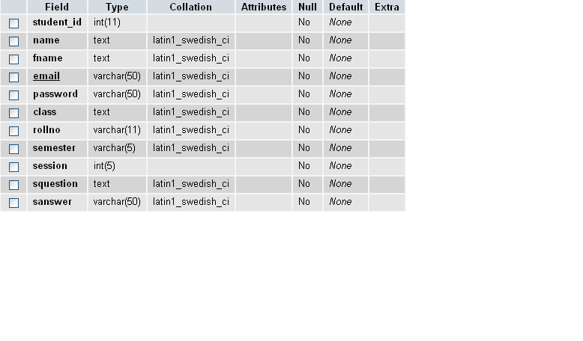

**4.2.2 Assignment Marks Table “assignment­_ marks”**

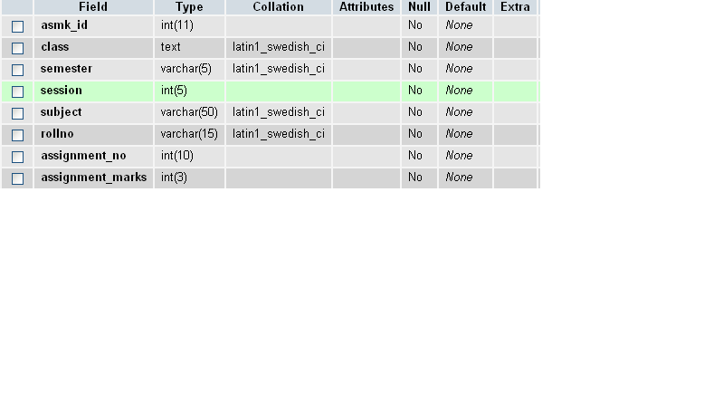

**4.2.3 Upload Assignment Table “upload_ assignment”**

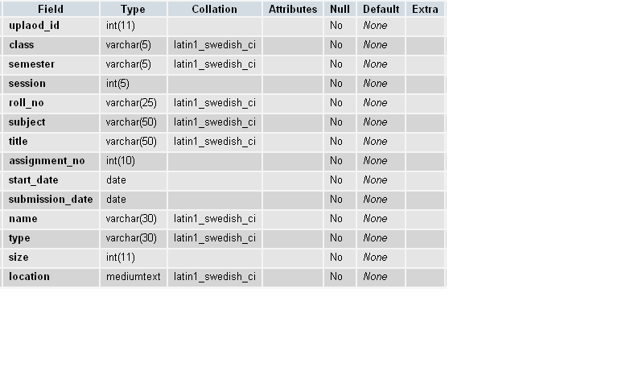

**4.2.4 Attendance Table “attendance”**

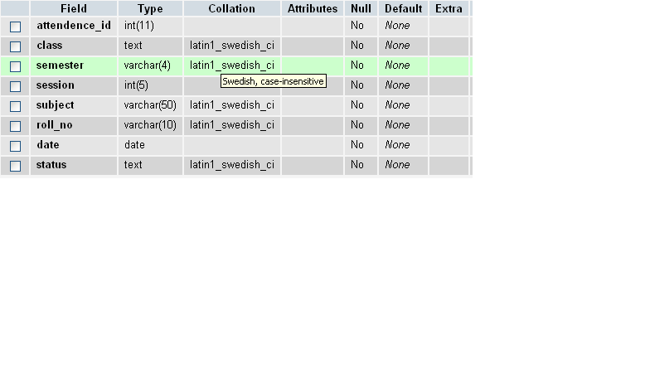

**4.2.5 Clerk Table “clerk_login”**

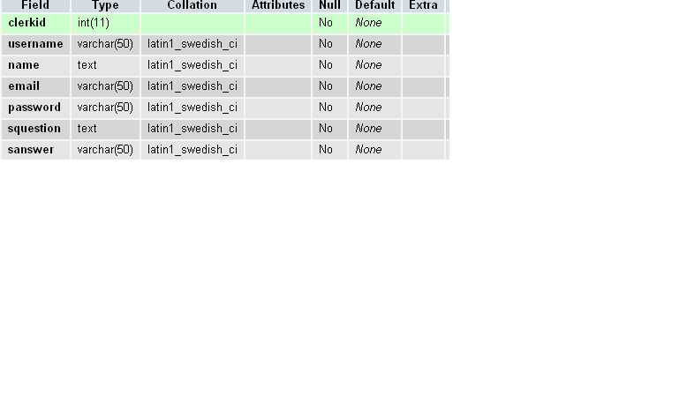

**4.2.6 Datesheet Table “datesheet”**

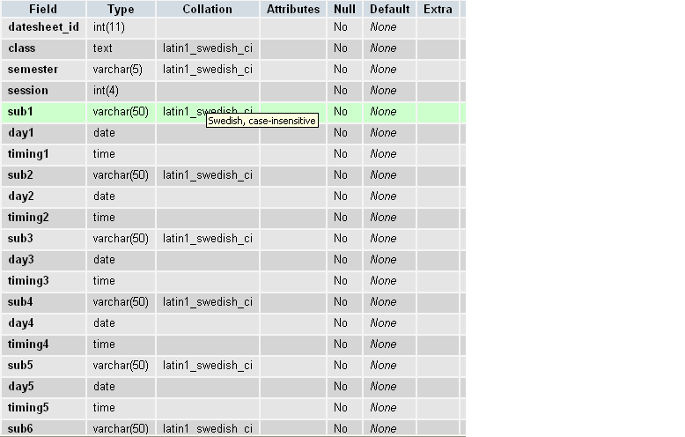

**4.2.7 E-Book Table “upload_ebook”**

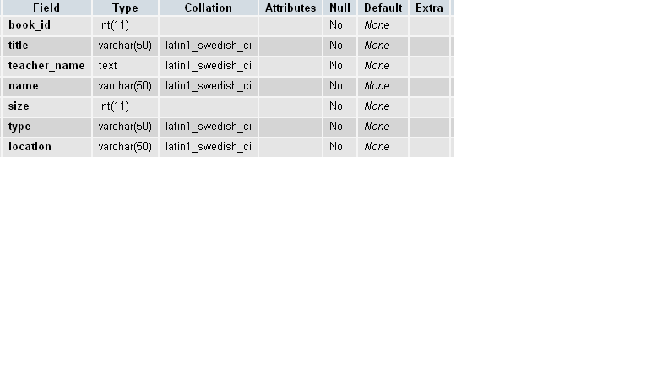

**4.2.8 Result Table “student_result”**

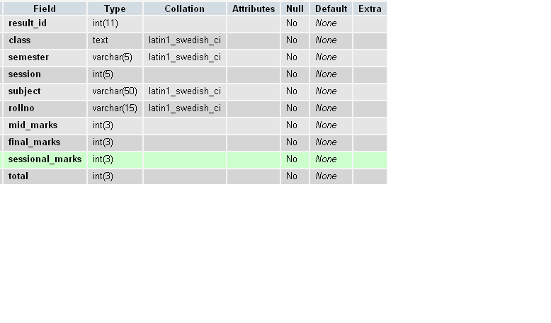

**4.2.9 Subject Table “subject_info”**

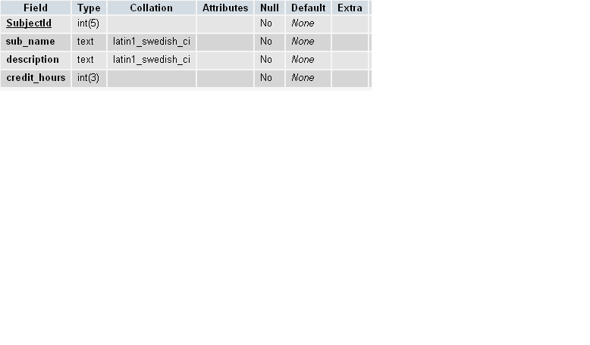

**4.2.10 Teacher Table “teacher_info”**

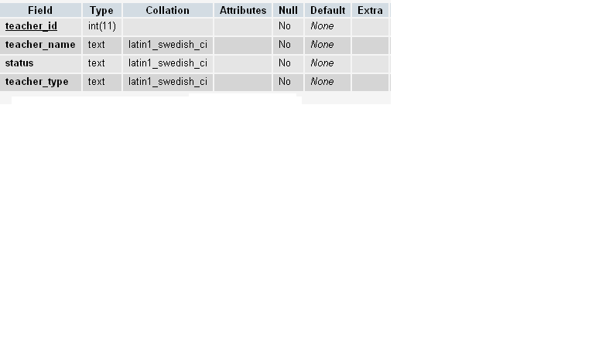

**4.2.11 Timetable Table “classes_timetable”**

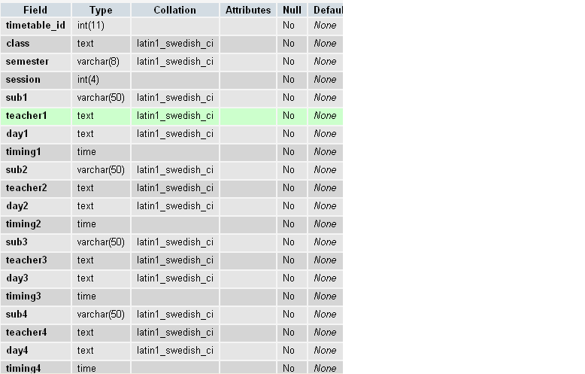

**4.2.12 Student Assignment Table “student_upload_assignment”**

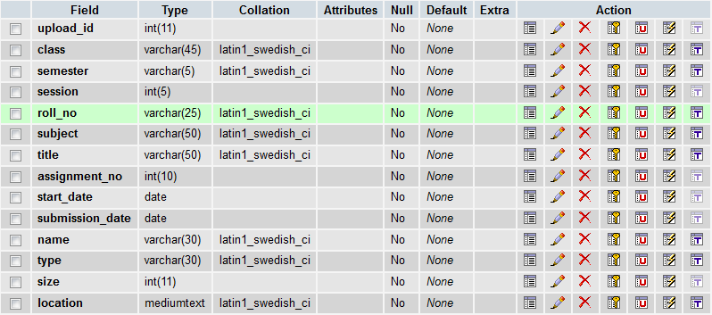

**4.2.13 Teacher Table “teacher_login”**

